EDGE INTELLIGENCE
LAB - 7

25MML0057
TARUN KUMAR R

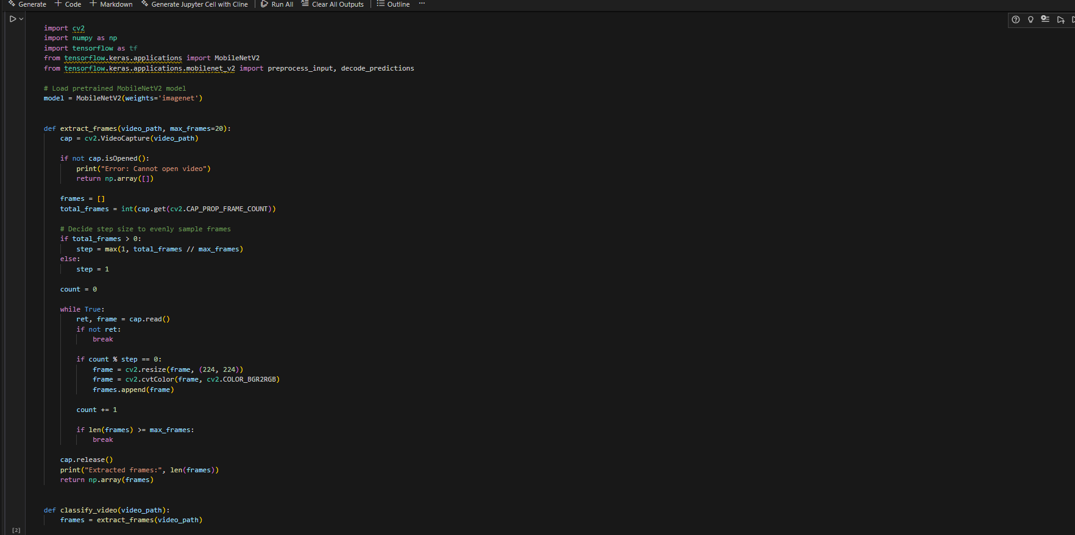
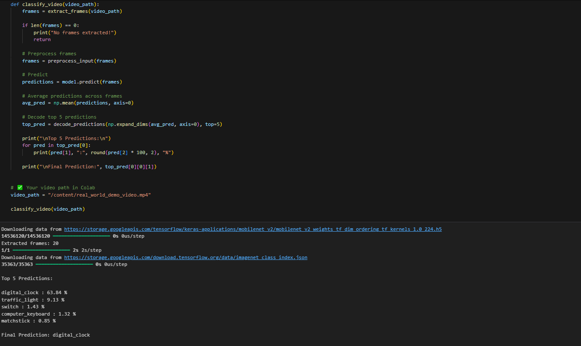
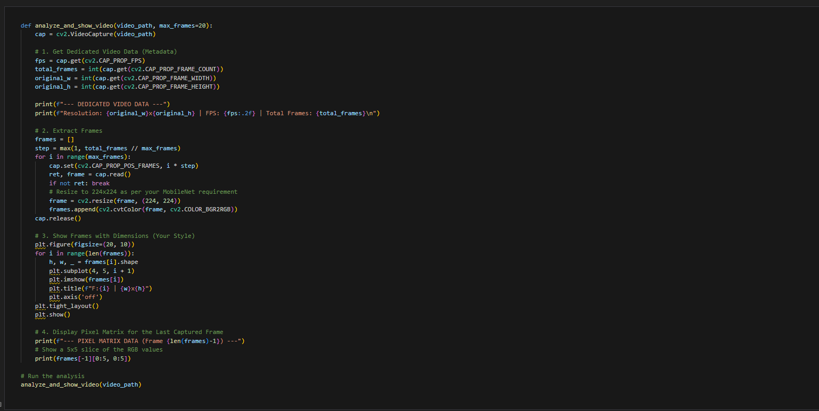

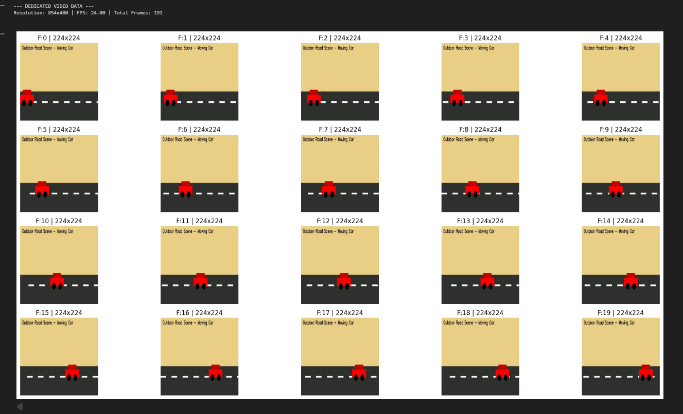
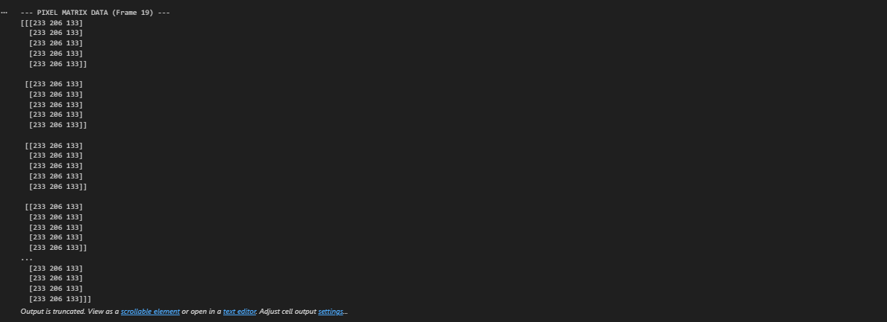
Step 1: Import the required libraries such as OpenCV for video processing and Matplotlib for visualization.
Step 2: Load the video file using video capture functionality to access the frames.
Step 3: Verify that the video file is successfully opened to prevent runtime errors.
Step 4: Read the video frame by frame using a loop structure.
Step 5: Select multiple frames at fixed intervals (for example, every 30th frame) instead of processing all frames to reduce redundancy.
Step 6: Convert the frame color format from BGR to RGB for proper visualization.
Step 7: Store the selected frames in a list for organized access and further processing.
TASK 2
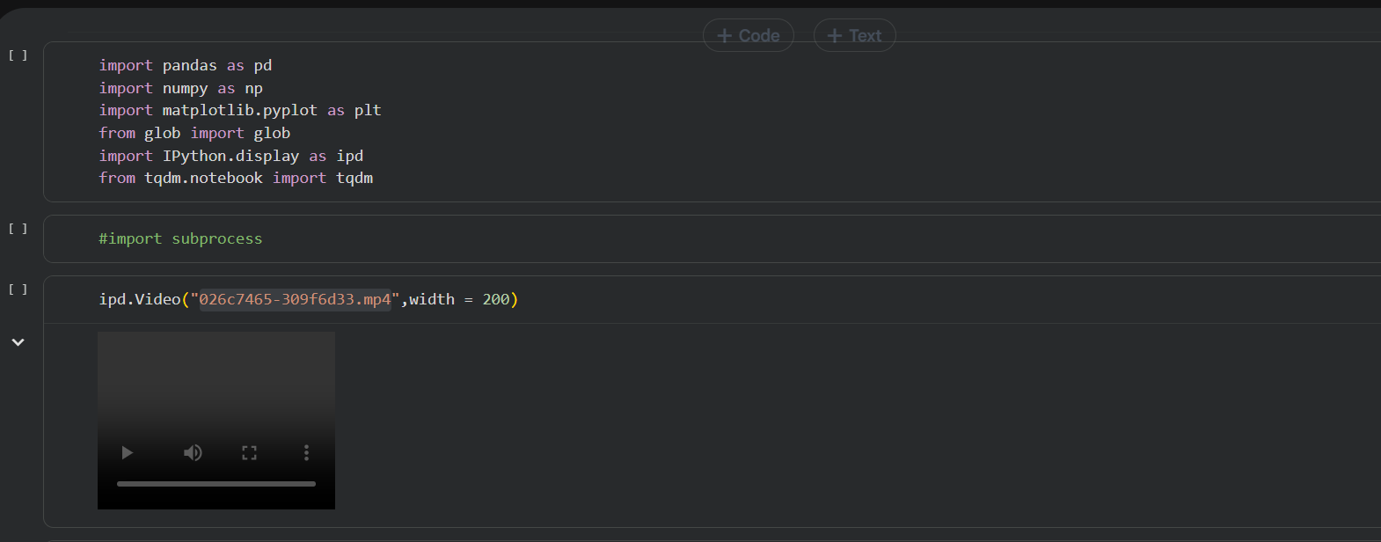
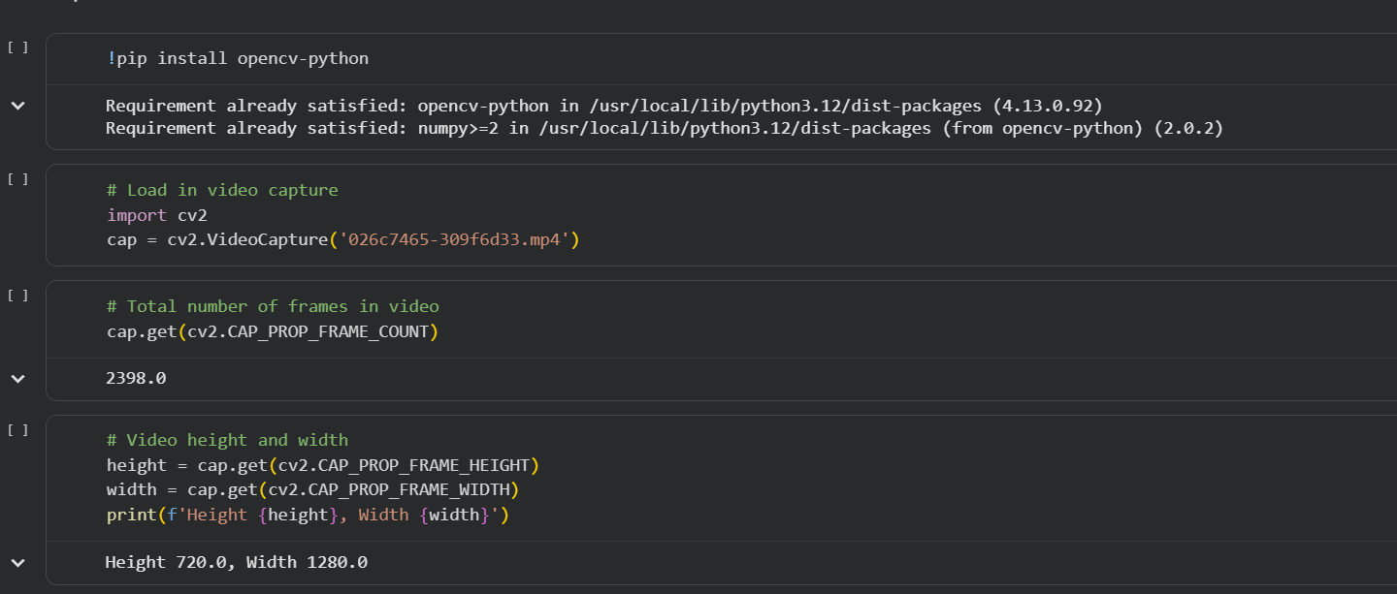
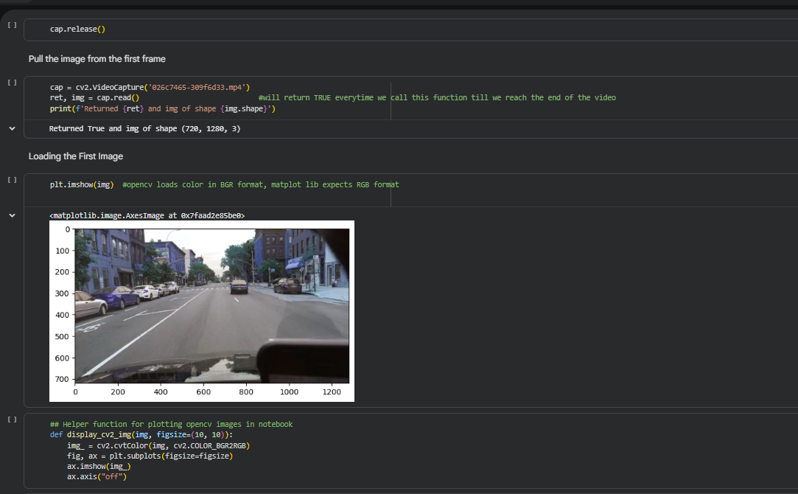
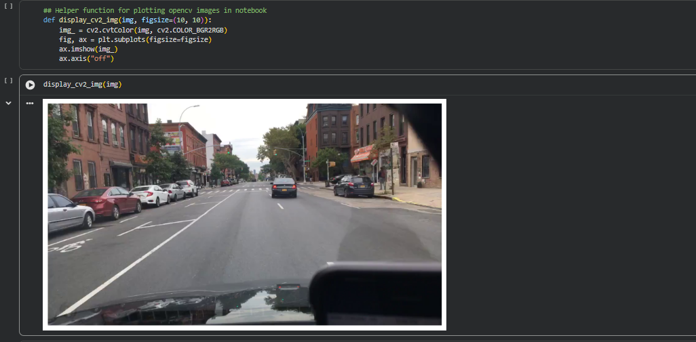
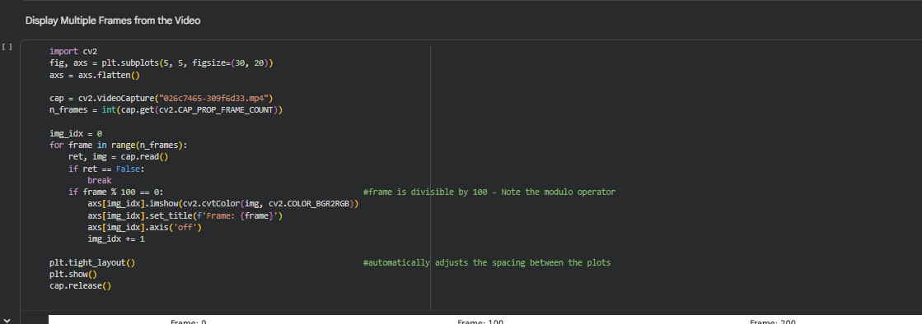
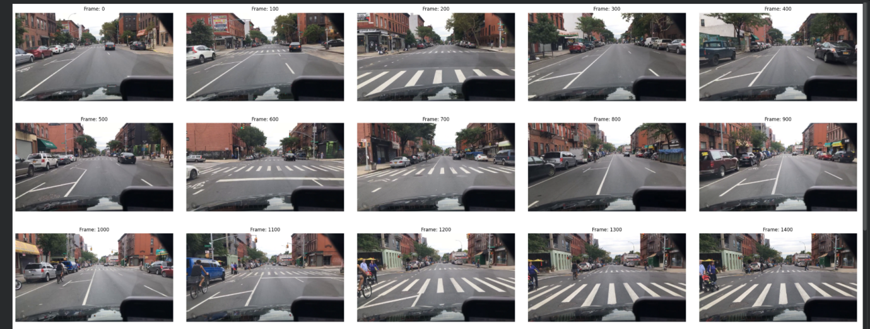
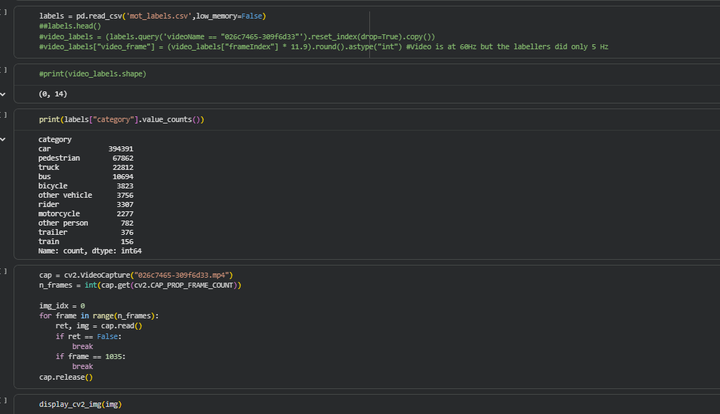
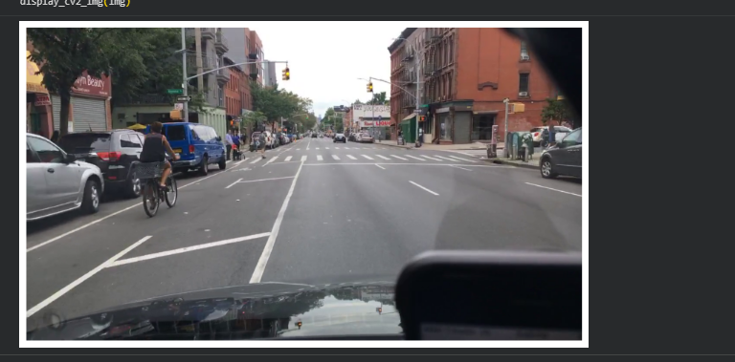

Step 1: Imported libraries like OpenCV to handle video processing tasks.
Step 2: Specified the path of the video file that needs to be processed or uploaded the file in the colab.
Step 3: Created a video capture object to load and access the video file.
Step 4: Checked whether the video file was successfully opened to ensure there were no loading errors.
Step 5: Read the video frame by frame using a loop structure.
Step 6: Displayed each frame of the video for visualization and verification.
Step 7: Controlled the playback speed using delay functions to simulate real-time video display.
Step 8: Added a condition to stop the video playback when a specific key was pressed.

